**Create a Testing Framework for Sporty Shoes Website**

In the project create 3 packages to maintain Base class, Page class and test classes

Step 1

Create the testbase file

**package** com.qa.sportshoes.base;

**import** org.openqa.selenium.WebDriver;

**import** org.openqa.selenium.chrome.ChromeDriver;

**public** **class** TestBase {

**public** **static** WebDriver *driver*;

**public** **static** **void** openBrowser()

{

*driver* = **new** ChromeDriver();

*driver*.manage().window().maximize();

*driver*.manage().deleteAllCookies();

*driver*.get("http://localhost:9010/");

}

**public** **void** closebrowser()

{

*driver*.close();

}

}

Step 2

Create the page class

**package** com.qa.sportshoes.Pages;

**import** org.openqa.selenium.WebDriver;

**import** org.openqa.selenium.WebElement;

**import** org.openqa.selenium.support.FindBy;

**import** org.openqa.selenium.support.PageFactory;

**import** com.qa.sportshoes.base.TestBase;

**public** **class** HomePage **extends** TestBase {

// driver.findElement(localtor).methods

// @FindBy(loacatorname="value")

// WebElement name;

@FindBy(linkText="New User? Register Here")

WebElement registerlink;

**public** HomePage(WebDriver driver)

{

PageFactory.*initElements*(driver, **this**);

}

// action methods

**public** **void** getURL_page()

{

String URL = *driver*.getCurrentUrl();

System.***out***.println(URL);

}

**public** **void** Click_registerlink()

{

registerlink.click();

}

}

Step 3

Create the homepagetest file

package com.qa.sportyshoes.Tests;

import org.testng.Assert;

import org.testng.annotations.Test;

import com.qa.sportshoes.Pages.HomePage;

import com.qa.sportshoes.base.TestBase;

public class HomePageTest extends TestBase {

HomePage hp;

@Test(priority='1')

public void start_browser()

{

openBrowser();

hp = new HomePage(driver);

}

@Test(priority='2')

public void test_getURL_method()

{

hp.getURL_page();

}

@Test(priority='2')

public void test_registerlink_method()

{

hp.Click_registerlink();

String expectedURL = "http://localhost:9010/register";

String RegisterPageURL = driver.getCurrentUrl();

Assert.assertEquals(RegisterPageURL, expectedURL);

}

}

Screenshots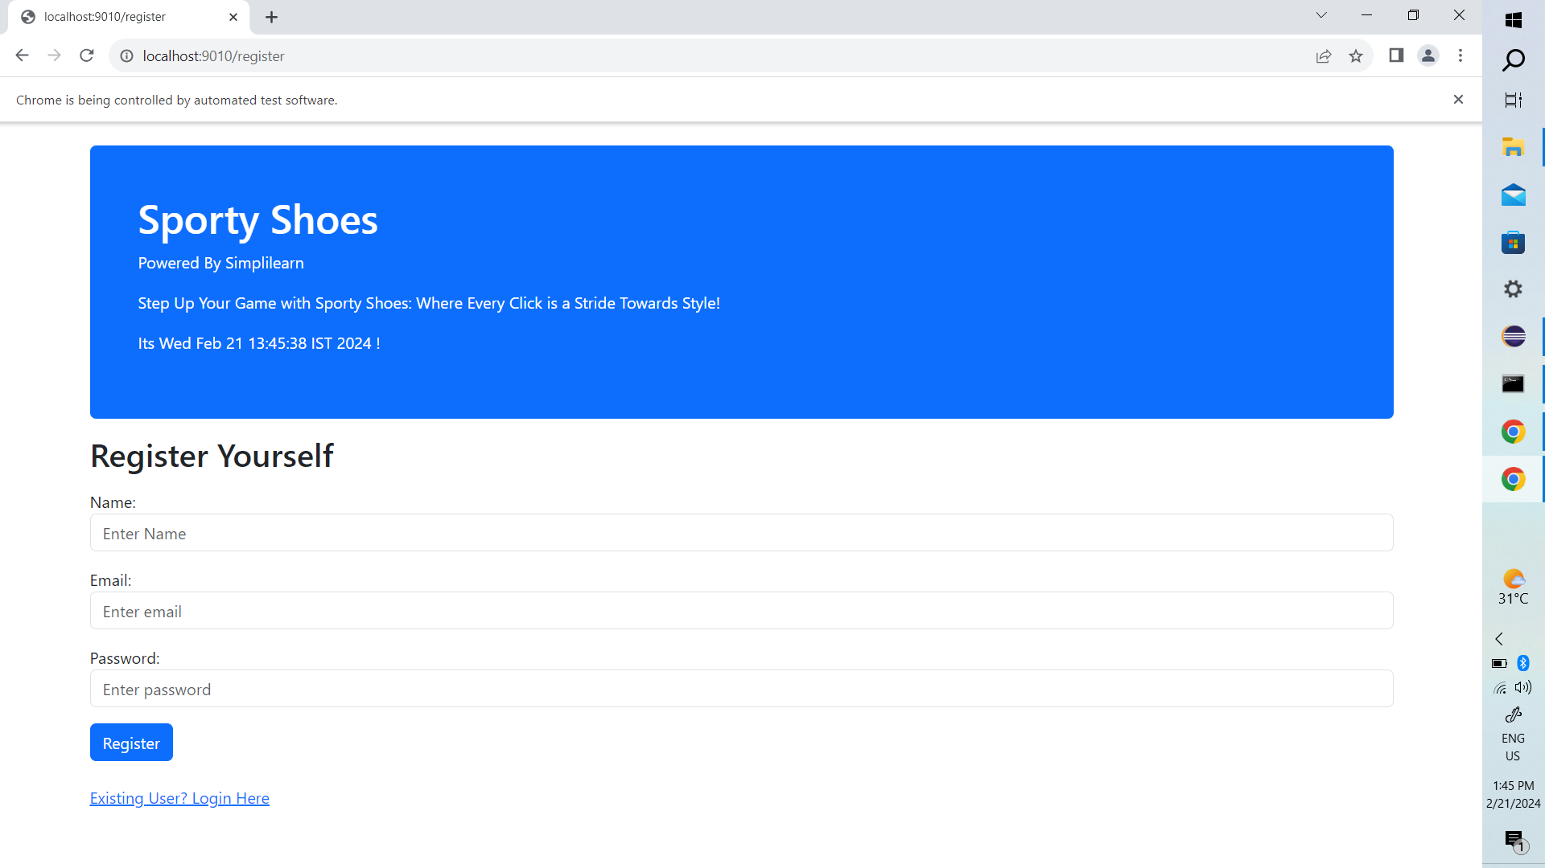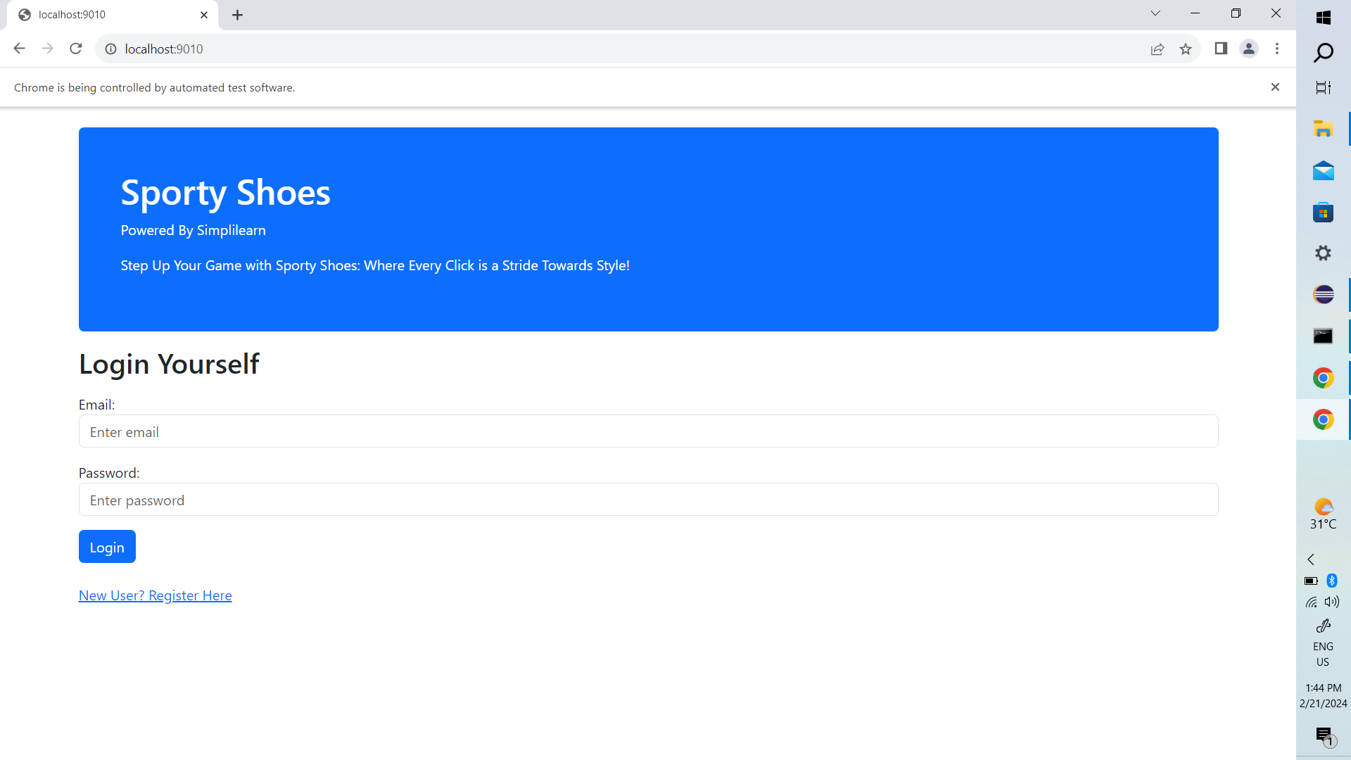

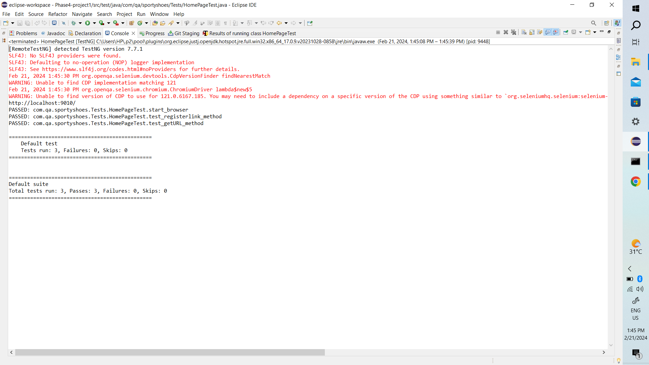

RegisterPage Classes:

package com.qa.sportshoes.Pages;

import org.openqa.selenium.WebDriver;

import org.openqa.selenium.WebElement;

import org.openqa.selenium.support.FindBy;

import org.openqa.selenium.support.PageFactory;

import org.testng.Assert;

import com.qa.sportshoes.base.TestBase;

public class RegisterPage extends TestBase {

@FindBy(xpath="//*[@id='name']")

WebElement registerName;

@FindBy(xpath="//input[@id='email']")

WebElement registerEmail;

@FindBy(xpath="//input[@id='password']")

WebElement registerPassword;

@FindBy(xpath="//*[@type='submit']")

WebElement registerBtn;

public RegisterPage(WebDriver driver)

{

PageFactory.initElements(driver, this);

}

public void register_user()

{

registerName.sendKeys("Arya");

registerEmail.sendKeys("arya@gmail.com");

registerPassword.sendKeys("arya@123");

registerBtn.click();

}

public void validate_url()

{

String expectedURL = "http://localhost:9010/register-user";

String RegisterPageURL = driver.getCurrentUrl();

Assert.assertEquals(RegisterPageURL, expectedURL);

}

}

Registerpage test file

package com.qa.sportyshoes.Tests;

import org.testng.annotations.BeforeClass;

import org.testng.annotations.Test;

import com.qa.sportshoes.Pages.HomePage;

import com.qa.sportshoes.Pages.RegisterPage;

import com.qa.sportshoes.base.TestBase;

public class RegisterPageTest extends TestBase{

HomePage hp;

RegisterPage rp;

@BeforeClass

public void OpenBrowser()

{

openBrowser();

hp = new HomePage(driver);

rp = new RegisterPage(driver);

}

@Test(priority='1')

public void test_click_registerLink() throws InterruptedException

{

Thread.sleep(1500);

hp.Click_registerlink();

}

@Test(priority='2')

public void test_register_user()

{

rp.register_user();

}

@Test(priority='3')

public void test_newUser_url()

{

rp.validate_url();

}

}

Screenshots

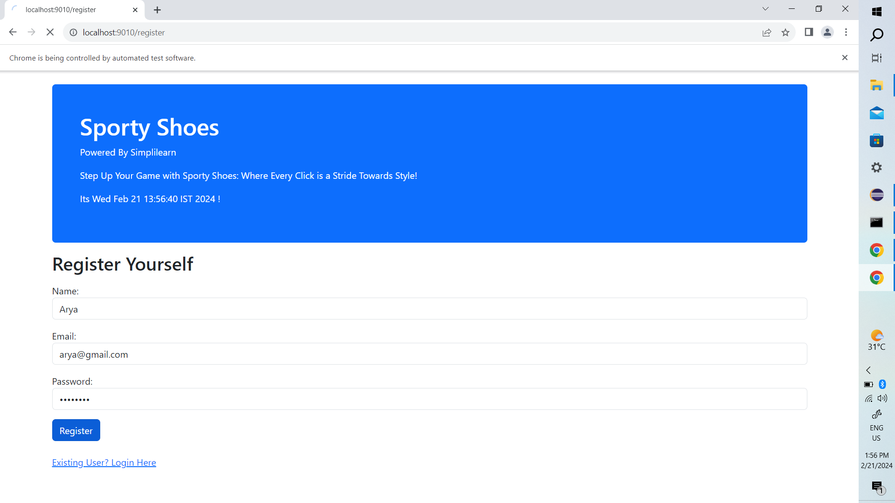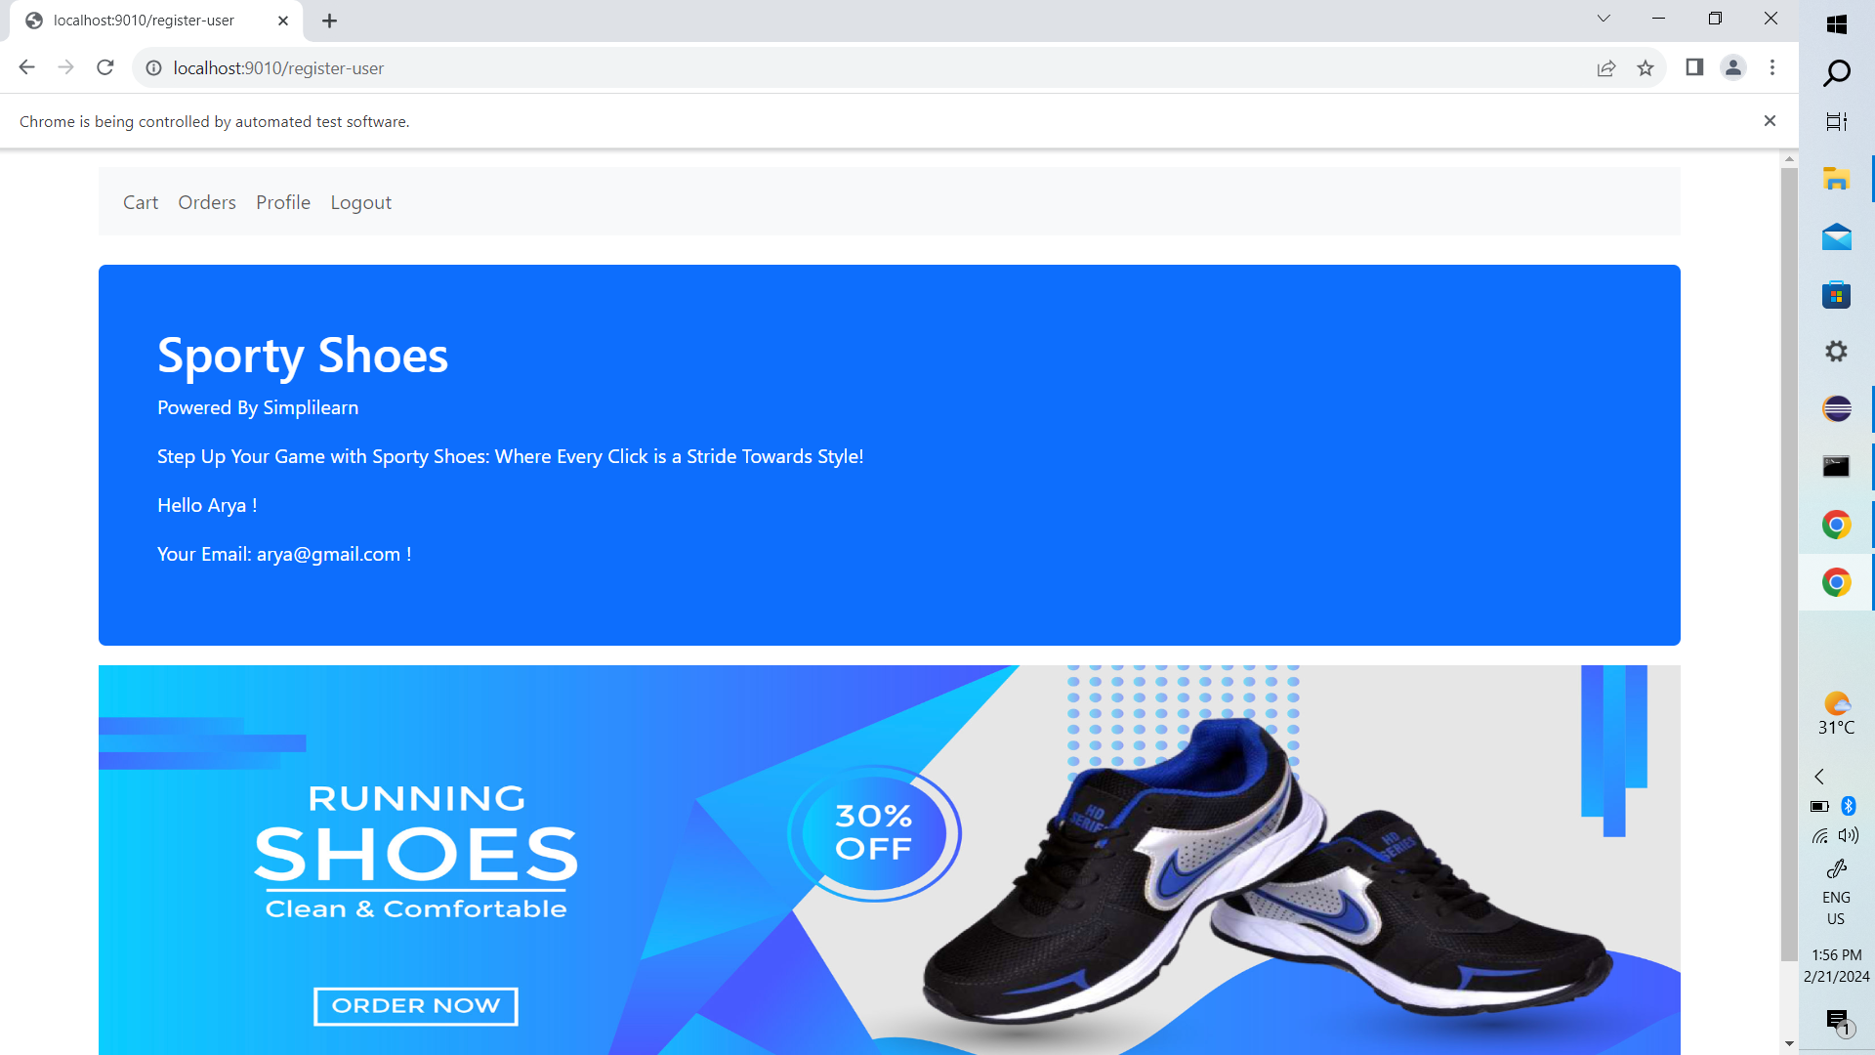

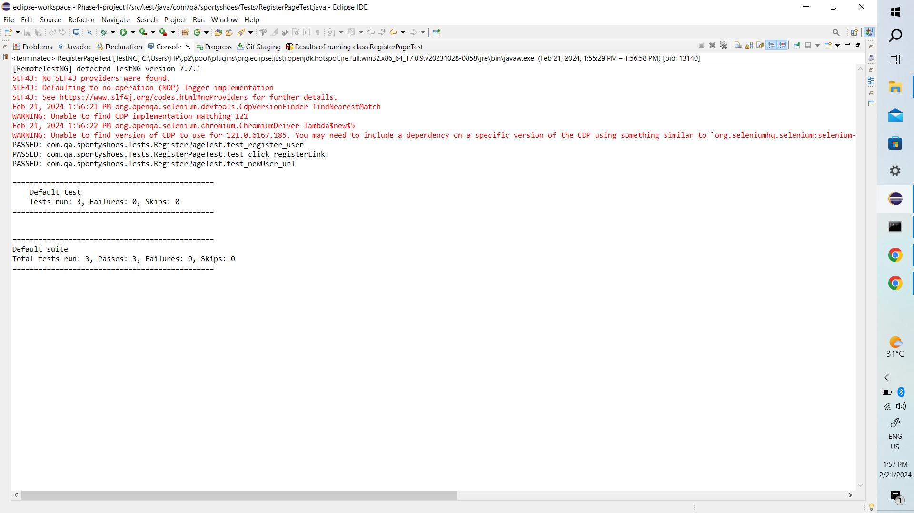

**LoginPage:**

package com.qa.sportshoes.Pages;

import org.openqa.selenium.WebDriver;

import org.openqa.selenium.WebElement;

import org.openqa.selenium.support.FindBy;

import org.openqa.selenium.support.PageFactory;

import org.testng.Assert;

import com.qa.sportshoes.base.TestBase;

public class LoginPage extends TestBase {

@FindBy(xpath="//*[@id='email']")

WebElement loginEmail;

@FindBy(xpath="//*[@id='password']")

WebElement LoginPassword;

@FindBy(xpath="//*[@type='submit']")

WebElement LoginBtn;

public LoginPage(WebDriver driver)

{

PageFactory.initElements(driver, this);

}

public void user_login()

{

loginEmail.sendKeys("arya@gmail.com");

LoginPassword.sendKeys("arya@123");

LoginBtn.click();

}

public void validate_loginPage_url()

{

String expectedURL = "http://localhost:9010/login";

String RegisterPageURL = driver.getCurrentUrl();

Assert.assertEquals(RegisterPageURL, expectedURL);

}

}

Loginpage test file

**package** com.qa.sportyshoes.Tests;

**import** org.testng.annotations.Test;

**import** com.qa.sportshoes.Pages.LoginPage;

**import** com.qa.sportshoes.base.TestBase;

**public** **class** LoginPageTest **extends** TestBase {

LoginPage lp;

@Test(priority='1')

**public** **void** start_browser()

{

*openBrowser*();

lp = **new** LoginPage(*driver*);

}

**public** **void** test_user_login() **throws** InterruptedException

{

Thread.*sleep*(1000);

lp.user_login();

}

**public** **void** test_validate_loginPage_url()

{

lp.validate_loginPage_url();

}

}

Screenshots

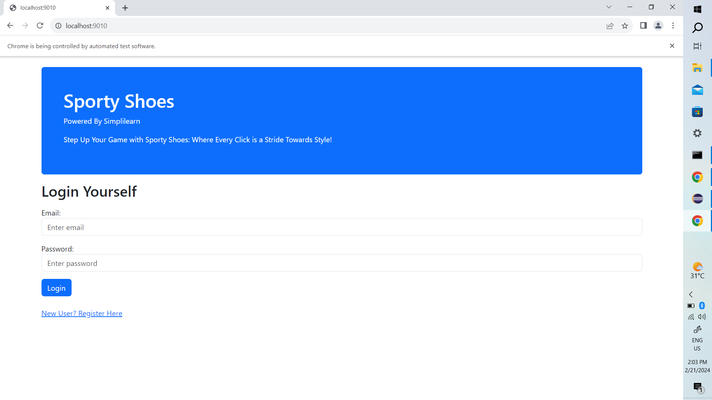

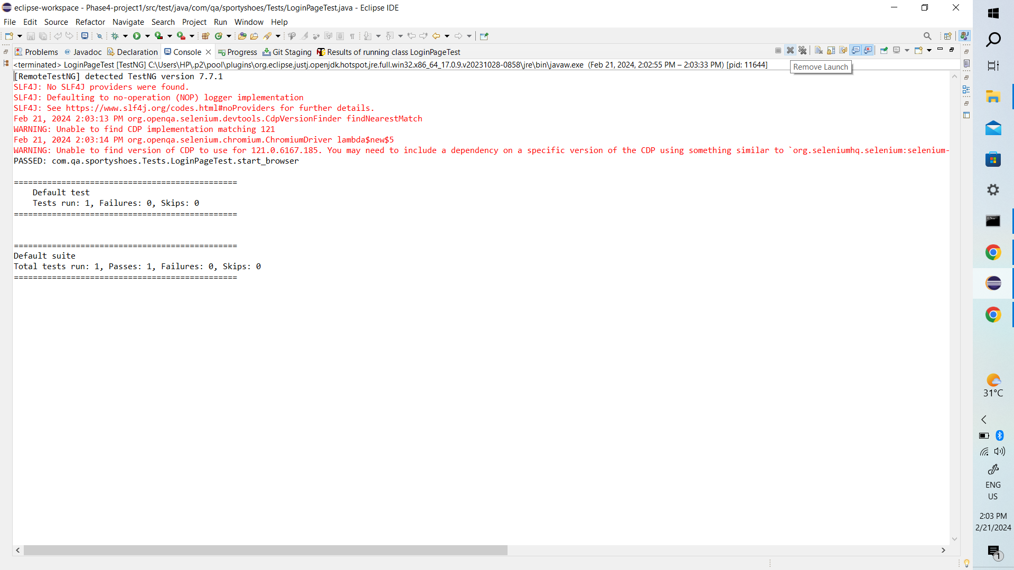

ProductsPage

package com.qa.sportshoes.Pages;

import org.openqa.selenium.JavascriptExecutor;

import org.openqa.selenium.WebDriver;

import org.openqa.selenium.WebElement;

import org.openqa.selenium.support.FindBy;

import org.openqa.selenium.support.PageFactory;

public class ProductsPage {

@FindBy(xpath="//*[@id='cart101']")

WebElement addtocartBTN;

@FindBy(linkText="Home")

WebElement HomeBTN;

@FindBy(linkText="Cart")

WebElement CartBTN;

@FindBy(xpath="//*[@id='place-order']")

WebElement placeOrderBTN;

@FindBy(linkText="Orders")

WebElement OrdersBTN;

@FindBy(linkText="Logout")

WebElement logoutBTN;

JavascriptExecutor executor;

public ProductsPage(WebDriver driver)

{

PageFactory.initElements(driver, this);

executor = (JavascriptExecutor) driver;

}

public void click_addtoCart()

{

executor.executeScript("arguments[0].click();", addtocartBTN);

}

public void click_homebtn()

{

HomeBTN.click();

}

public void click_cartbtn()

{

CartBTN.click();

}

public void click_placeorder()

{

executor.executeScript("arguments[0].click();", placeOrderBTN);

}

public void click_Ordersbtn()

{

OrdersBTN.click();

}

public void click_Logoutbtn()

{

logoutBTN.click();

}

}

ProductsTest

package com.qa.sportyshoes.Tests;

import org.testng.annotations.BeforeClass;

import org.testng.annotations.Test;

import com.qa.sportshoes.Pages.LoginPage;

import com.qa.sportshoes.Pages.ProductsPage;

import com.qa.sportshoes.base.TestBase;

public class ProductsTest extends TestBase {

LoginPage lp;

ProductsPage pp;

@BeforeClass

public void start_browser()

{

openBrowser();

lp = new LoginPage(driver);

pp = new ProductsPage(driver);

}

@Test(priority='1')

public void test_user_login() throws InterruptedException

{

Thread.sleep(1000);

lp.user_login();

}

@Test(priority='2')

public void test_product_addtoCart() throws InterruptedException

{

Thread.sleep(1000);

pp.click_addtoCart();

}

@Test(priority='3')

public void test_HomeBTN() throws InterruptedException

{

Thread.sleep(1000);

pp.click_homebtn();

}

@Test(priority='4')

public void test_CartBTN() throws InterruptedException

{

Thread.sleep(1000);

pp.click_cartbtn();

}

@Test(priority='5')

public void test_placeorderBTN() throws InterruptedException

{

Thread.sleep(1000);

pp.click_placeorder();

}

@Test(priority='6')

public void test_orders() throws InterruptedException

{

Thread.sleep(1000);

pp.click_homebtn();

pp.click_Ordersbtn();

}

@Test(priority='7')

public void test_logout() throws InterruptedException

{

Thread.sleep(1000);

pp.click_Logoutbtn();

}

}

Screenshots